Using the Ori DE Randomizer Graphical Seed Generator

By David Miller

1. **Prerequisites**:
   * Python 2.7 (the seed generator script might be Python 3 compatible but I haven’t personally tested it)

Download this from the Python website:

<https://www.python.org/downloads/release/python-2713/>

When you are installing this make sure that you select the ‘Add python.exe to Path’ option as shown below

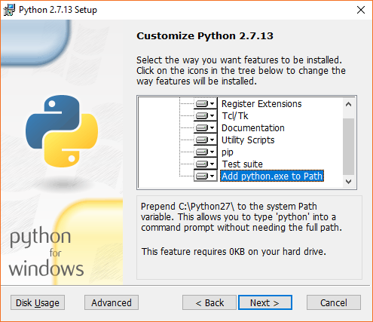

After you are done, you can verify that this is working by running the following in command prompt (Win+R and run ‘cmd’):

python –version

The output should be 2.7.x depending on which version of Python 2.7 you’re running. If this is not the case then the GUI seed generator will **not** work. It should look like the first line in the picture below. There is an intentional typo in the second command to show what it would look like if python is not in the path.

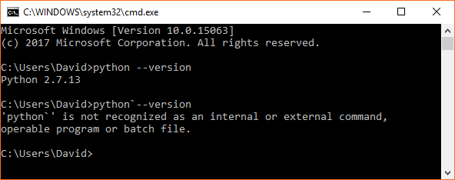

* .NET Framework 4.5

You can download this from the Microsoft website if you don’t already have it: <https://www.microsoft.com/en-us/download/details.aspx?id=40779>

1. **Downloading the executable**

The most recent version can be found here:

<https://github.com/david-c-miller/OriDERandomizerSeedGenGUI/releases/latest>

Download the compressed file (OriDERandoSeedGeneratorUI-vx.x.x.zip) with the python script, the GUI, and the logic information. You need to uncompress this folder and then run the executable (OriDERandoSeedGeneratorGUI.exe).

Make sure that the python script (seed_generator.py) and the logic information (areas.xml) are in the same folder as the executable.

1. **Using the Seed Generator**
2. Select the folder you want to save the seed to by either clicking the folder icon or typing the path in the text box.
3. Choose the logic options, which can either be one of the presets from the list on the left side (under ‘Logic Groups’) or ‘Custom’ at the bottom
4. If you choose ‘Custom’ select the other logic choices, challenges, and pickup options from the check boxes in the center and right
5. Choose a seed number or click the random button to select the number with a random number generator
6. Select the number of contiguous seeds to output (i.e. if you select seed 5 and choose 10 seeds then you will get 5, 6, 7, …, 13, and 14)

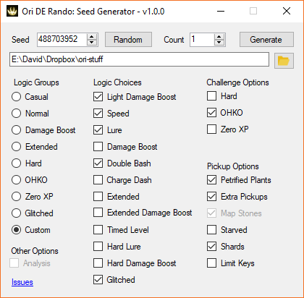

If you run into any problems please submit an issue on the GitHub page. You can either click the link on the bottom left corner or go here:

<https://github.com/david-c-miller/OriDERandomizerSeedGenGUI/issues>

Thanks

First, thanks to Sigma for making the Ori DE Randomizer: <https://github.com/sigmasin/OriDERandomizer>

Also, a big thanks to the whole Ori community!